**R Code for Examples in the book**

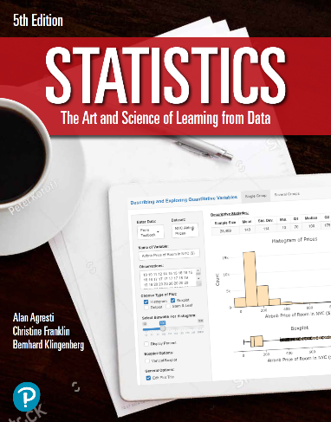

***“Statistics: The Art and Science of Learning from Data”***

**by Agresti, Franklin and Klingenberg, 5th edition**

**Chapter 6**

**Example 8: Mensa IQ Scores – Cumulative Probability and Percentiles**

## To find the 98th percentile for Mensa membership

qnorm(0.98, mean = 100, sd = 16)

## [1] 132.86